**Python Assignment**

**QUESTION 1:- Find the data type of these two declarations:**

x=5

y="John"

**SOLUTION:-**

x=5

print(type(x))

Result <class 'int'>

y=’John’

print(type(y))

Result <class 'str'>

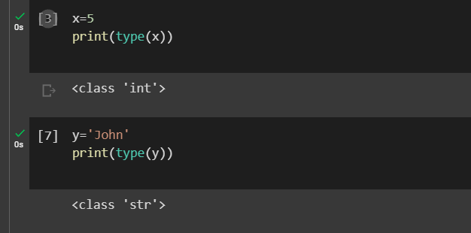

**QUESTION 2:- Check whether the following syntax is valid or invalid for naming a variable. : Example: abc=100 #valid syntax**

**SOLUTION:-**

3a=10 #Invalid Syntax

@abc=10 # Invalid Syntax

a100=100 #Valid Syntax

a984_=100 #Valid Syntax

a9967$=100 #Invalid Syntax

xyz-2=100 #Invalid Syntax

**QUESTION 3:- Check if element exists in list in Python:**

**test_list=[1,6,3,5,3,4]**

**Check if 3 exist or not.**

**Check if 9 exists or not.**

**SOLUTION:-**

test_list=[1,6,3,5,3,4]

if 3 in test_list:  
 print("3 in test_list")

else:  
 print("3 is not in test_list")

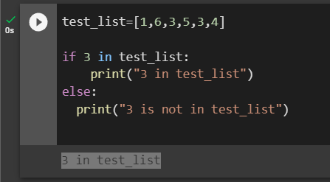

test_list=[1,6,3,5,3,4]  
if 9 in test_list:  
 print("9 is in test_list")  
else:  
 print("9 is not in test_list")

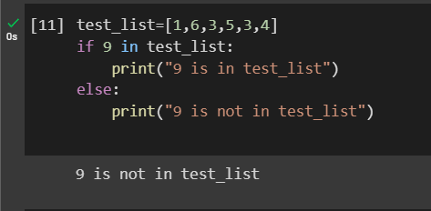

**QUESTION 4:- Take the user input to print the current date**

**SOLUTION:-**

from datetime import date  
today = date.today()  
print("Today date is: ", today)

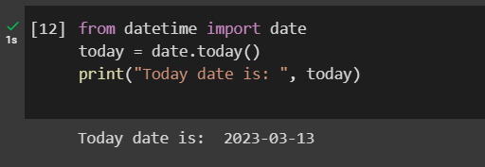

**QUESTION 5:- What is the out put of the following code:**

a.print 9//2

b.print 9%2

**SOLUTION:-**

**Without tuples error was coming.**

**With tuples below results found:**

print(9//2)

Result 4

print(9%2)

Result 1

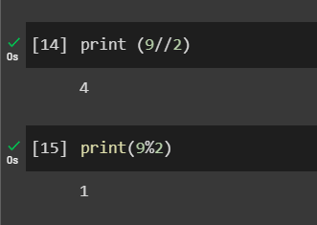

**QUESTION 6:- Print First 10 natural numbers using a while loop?**

**SOLUTION:-**

i = 1  
while(i<=10):  
 print(i)  
 i += 1

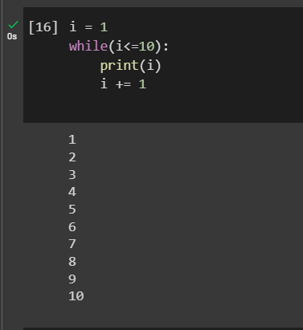

**QUESTION 7:- Write a program to accept a number from a user and calculate the sum of all numbers from 1 to a given number**

**For example, If the user entered 10 the output should be 55 (1+2+3+4+5+6+7+8+9+10)**

**SOLUTION:-**

n = int(input("Enter a number: "))

s = 0

for i in range(n + 1):

s += i

print("The sum of all numbers from 1 to the given number is: ", s)

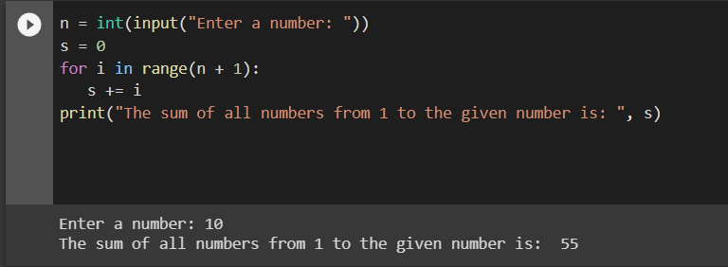

**QUESTION 8:- Write a Python program which iterates the integers from 1 to 50. For multiples of three print "Fizz" instead of the number and for the multiples of five print "Buzz". For numbers which are multiples of both three and five print "FizzBuzz".**

**SOLUTION:-**

for FizzBuzz in range(51):

if FizzBuzz % 3 == 0 and FizzBuzz % 5 == 0:

print("FizzBuzz")

continue

elif FizzBuzz % 3 == 0:

print("Fizz")

continue

elif FizzBuzz % 5 == 0:

print("Buzz")

continue

print(FizzBuzz)

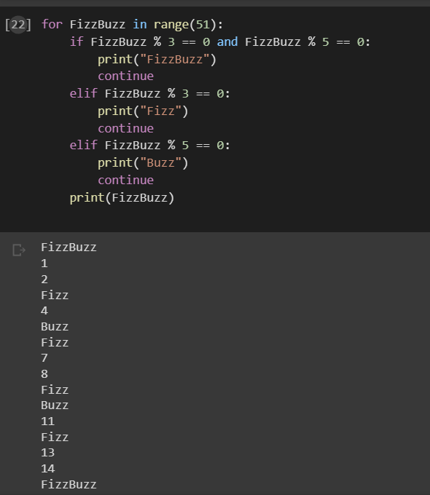

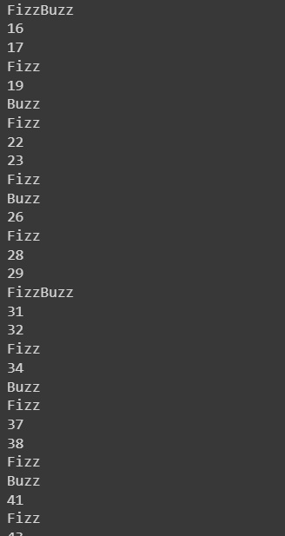 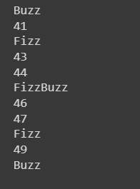

END